PROJECT DESIGN PHASE 1

SOLUTION ARCHITECTURE

|  |  |
| --- | --- |
| TEAM ID | PNT2022TMID13652 |
| PROJECT NAME | SMART WASTE MANAGEMENT SYSTEM FOR METROPOLITAN CITIES |

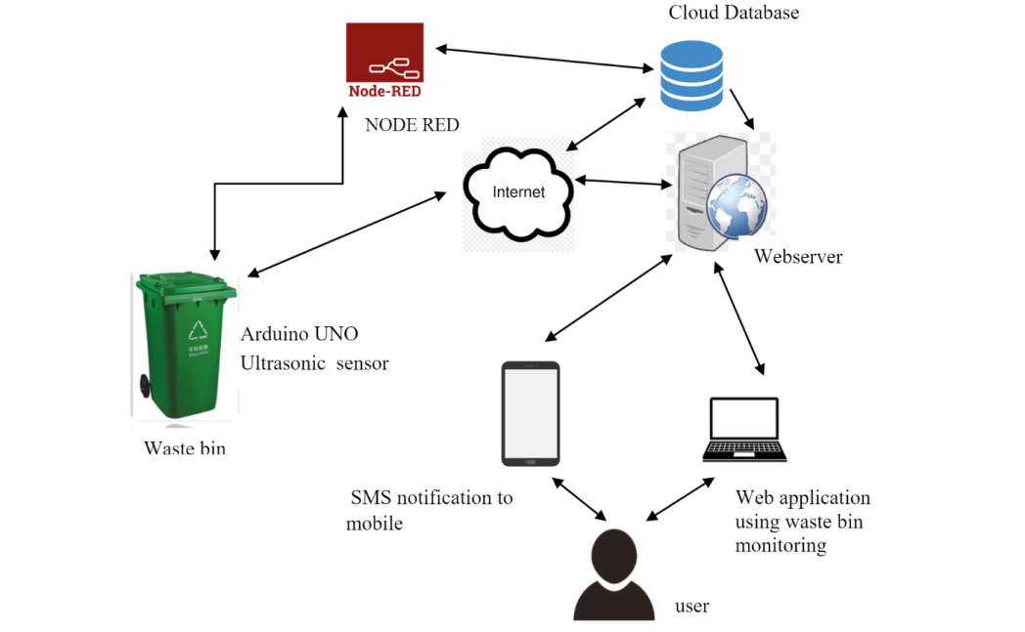

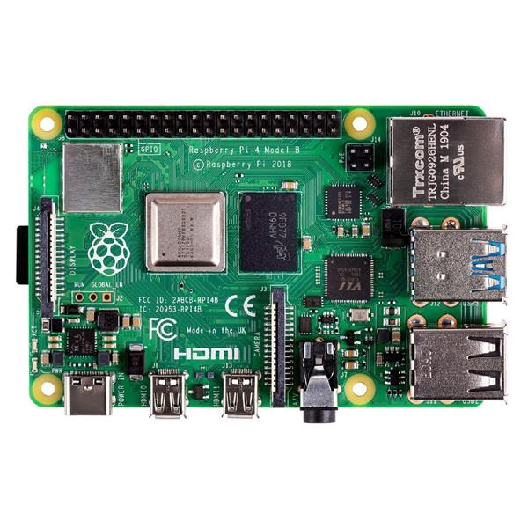 **Raspberry pi**

